UNIVERSITY OF SALFORD STUDENTS’ UNION

APPLICATION PACK:
Student Chef

October 2018

Notes for Applicants

Section One – Governance

We hope that by reading this information it will tell you a bit more about how the Students’ Union works and how the current governance and Resources are managed.

1.1 The Students’ Union

The University of Salford Students’ Union is the independent representative body of students at the University. The Students’ Union is a registered charity.

Our Mission (why do we exist):

We exist to serve students and inspire them to lead their development

Our Vision (what we want to be): to be…….

“the outstanding organisation in the UK for delivering a positive student experience.”

Our Values:

The best thing about the University of Salford Students’ Union (USSU) is our culture. As we grow, we want to have a culture that we are proud to share with anyone who comes into contact with the Students’ Union.
We have six core values to define what exactly the USSU culture is. They are reflected in everything we do and every interaction we have. Our core values are always the framework from which we make all of our decisions.

We are……….

Passionate: being enthusiastic and believing in students
Devoted to Integrity: owning our behaviour and practicing what we preach
Dedicated: having an in-depth understanding of all our students and their needs
Ambitious: using innovative thinking to be the best
Open: being transparent, accountable, sharing ideas and information
Enthusiastic about Equality: bringing fairness and equality of opportunity into everything we do

The Union’s new Strategic Plan for 2015 - 2018 states that the Union will achieve its mission by pursuing four themes:
- Support students to build authentic communities
- Provide opportunities for all students to create life changing experiences for themselves and others
- Provide a strong, democratic voice for students at local and national level
- Encourage students to take care of their wellbeing

1.2 Governance

The Union is democratically controlled by its members through the annual election of a team of student representatives who form the Union’s Trustee Board. The membership of the Trustee Board is as follows:
- Five Sabbatical Trustees (1 x President, 4 x Students’ Union Officers each of whom is responsible for one of the University’s 4 academic Schools)
- Four Student Trustees (appointed by the sabbatical officers and external trustees)
- Four Non Student Trustees (appointed by the sabbatical and student trustees)

The Trustees determine policy for all areas of Union activity. The Sabbatical Trustees are full time officers of the organisation and work for the Union for a year either during or at the end of their degree course in order to represent students on a full time basis

The Sabbatical Trustees work alongside the permanent Union staff to implement and carry out the strategy and policies set by the Trustee Board. The permanent staff team is managed by the Chief Executive, who is directly accountable to the Trustee Board for the Union’s performance.

1.3 Finance & resources

The Union receives an annual grant from the University to fund its activities, and has an annual turnover from its commercial operations in excess of £2m. The grant and the surpluses generated from the commercial operations enables the Union to spend over £900,000 on the direct provision of student representation, recreation and development activities. 35 people make up the permanent staff team and approximately 50 student casual staff members are employed on a seasonal basis. The Union has approximately 18,500 student members and provides services to a further 2,500 people who work in the University.

The Union’s offices are located on the main University campus, with some of its commercial services located elsewhere around the University. Staff may be required to work at any of these locations either temporarily or permanently, however, the Union does take personal circumstances into account as far as possible when deciding who works where.

1.4 Student services

The Union is involved in a very wide range of activities. Its core purpose is to represent students and provide activities for them to enhance the student experience. The Union organises campaigns on issues of concern to the generality of students, administers the work of over 110 different student sport/activity groups, trains and develops over 500 student representatives and operates a Student Advice Centre.

The Union’s commercial activities and interests include a food led licensed venue and events throughout the year. The Union also has a partnership approach to delivering a retail offer on campus.

1.5 Our Strategic Plan

The themes and goals within the strategic plan 2015-2018 are:

Supporting students to build authentic communities

Goal One: Develop a vibrant USSU, providing excellent accessible facilities, activities and services that are friendly and meet the aspirations of all our students.

Goal Two: Create extensive opportunities for students to engage with USSU, and build communities anywhere, 24 hours a day, 7 days a week.

Opportunities to create life changing experiences

Goal Three: Develop a vibrant student community by providing sport, activities, volunteering and employment opportunities
Goal Four: Build a culture that encourages new ideas and captures the energy of our students and staff to create an innovative and responsive Students’ Union.

A strong, democratic voice for students at local and national level

Goal Five: Champion student interests, providing all students with a strong effective voice by supporting and empowering them, collectively and individually.
Goal Six: Embed democracy at the heart of USSU; valued by all our students and staff.

Encourage and enable students to take care of their wellbeing

Goal Seven: To engage students in considering their wellbeing as a way of helping to reach their full potential.

Goal Eight: To ensure all students have access to the right advice, services and activities to support their wellbeing.
The new staffing structure is shown on the next page.

Staffing Structure
The organisation is currently undergoing staffing re-structure to support the delivery of the strategic plan.
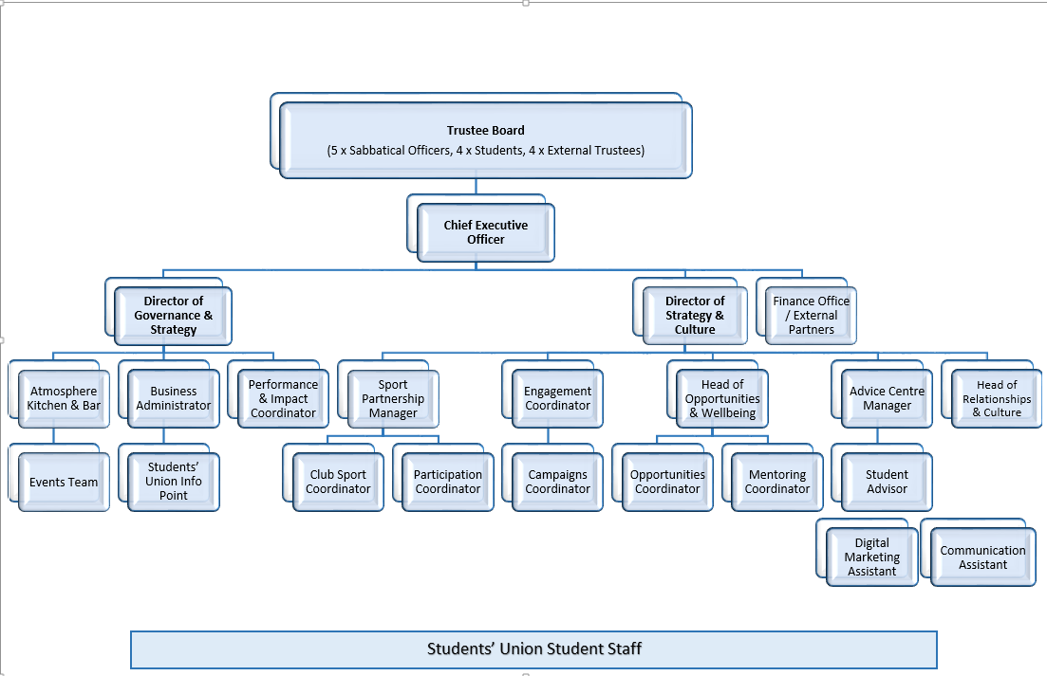

Section Two – Role Description

Job title: Student Chef – Atmosphere Kitchen and Bar
Responsible to: Head of Bars and Catering/Deputy Managers
Responsible for: None
Purpose of the post: To support the operation of the kitchen and catering service offered by Atmosphere ensuring a services which is of high standard and in line with Union processes, procedures and values

Main duties and responsibilities:
- To provide high level of customer service and standards

- To promote a positive image for the Students’ Union

- Under the direction of the Department Head deliver the food service and ensure meals are prepared and cooked to specification whilst maintaining a safe and hygienic working environment

- To maintain an up-to-date knowledge of products, services and the sector

- To comply with Students Union’s internal procedures and all external legal requirements to include Health & Safety, Food Management, Fire Safety and Licensing regulations

- To ensure you remain knowledgeable about products, services and offers in Atmosphere and the Union more broadly.

- To operate, clean and maintain all equipment safely in accordance with training

- To ensure that all catering areas are maintained in a clean and tidy manner. To wash up utensils and equipment.

- To use equipment and utensils efficiently, to maintain proper portion control and ensure minimum wastage.

- To assist in ensuring food is delivered to specification ensuring gross profit is maintained

- To assist in the control of wastage and keeping accurate records

- To ensure that goods and products are displayed properly and presented to a high standard

- Ensure all areas of the work environment are hygienic, tidy and free of hazards at all times.

- Use correct methods and materials for cleaning with strict adherence to instructions written on cleaning products.

- Provide full information to the manager relating to any incidents involving problems with customers, equipment or goods

- Be responsible for the completion of additional tasks relating to your role upon request by the Senior and Line Manager

Equality and diversity statement

We care about the diversity of our members and staff and believe that what makes us different is what makes us better. We are committed to providing a workplace that embraces diversity, is enthusiastic about equality and promotes opportunity for all.

Our organisation (University of Salford Students’ Union - USSU) welcomes applications from black and minority ethnic candidates as they are under-represented within the USSU workforce.
We will provide equality of opportunity and will not tolerate discrimination on grounds of gender, gender identity, marital status, sexual orientation, race, colour, nationality, religion, age, disability, HIV positivity, working pattern, sub culture, caring responsibilities, political beliefs – or any other grounds.
We will demonstrate our commitment by:
• promoting equality of opportunity and diversity within the environment we operate in
• treating our customers, colleagues and partners fairly and with respect
• building a workforce which reflects our students, aiming for even representation
• encouraging recruitment from groups currently under-represented
• promoting an environment free from discrimination, bullying and harassment, and tackling behaviour which breaches this through our senate sanctioned Zero Tolerance policy
• recognising and valuing the differences and individual contribution that people make
• ensuring people have a healthy and nice environment to work, develop and grow in through our ‘great place to work’ measures
• operating above and beyond our charitable and legislative requirements and best practice
• expecting and receiving excellence from all staff on these commitments – ensuring all staff are personally responsible for promoting these principles

Section Two – Person Specification

Applicants should demonstrate evidence of the following criteria in their applications. We will use a range of selection methods to measure candidates’ abilities in these areas including reviewing your online application, seeking references, inviting shortlisted candidates to interview and other forms of assessment action relevant to the post.
E is Essential, D is Desirable
 | E | D | Tested by
Qualifications and Experience

University of Salford Student | x |  | A
Basic food hygiene qualification |  | x | A
Previous bar, kitchen or catering experience |  | x | A/I
Previous experience of working within regulations around Health and Safety, fire safety and food hygiene in accordance with legislation |  | x | A/I
Skills and Abilities
Excellent interpersonal and communication skills | x |  | A/I
Ability to manage tasks and priorities | x |  | A/I
Ability to work in a team and form positive relationships with colleagues | x |  | I
Self-motivated and self-reliant | x |  | I
Good level of numeracy | X |  | I
Excellent customer service skills | X |  | A/I
Knowledge and Understanding
A understanding of Students’ Unions |  | X | A
An understanding of customer service standards |  | x | A/I
A knowledge of relevant H&S, Risk Assessment, Food Hygiene and Fire Regulations. |  | x | A/I/T
Values and personal qualities
Desire to work within a democratic student led environment. | X |  | A/ I
Understanding and commitment to equal opportunities. | X |  | A/I
Desire to work within an organization servicing a culturally diverse membership. | X |  | A/I
Committed, positive, outgoing and approachable with a ‘can do’ attitude. | X |  | A
Demonstrably high standards of personal integrity. | X |  | I
Motivated to deliver success | X |  | I
Tested by: A (Application form), P (Presentation), I (Interview). AC (Assessment Centre), T (Trail)

